PERSON SPECIFICATION FOR POST OF EYFS  CLASS TEACHER AT ST CRISPIN’S CP INFANT SCHOOL | 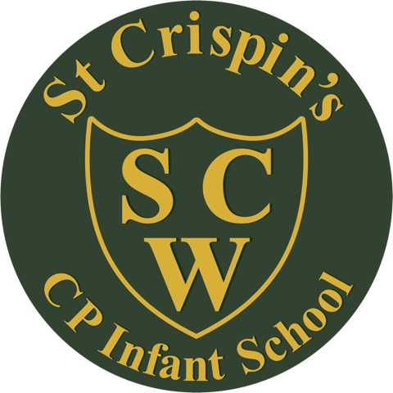

CRITERIA | ESSENTIAL | DESIRABLE
Qualifications and Experience | - Qualified teacher status.  - Successful experience of teaching in EYFS. | - Experience of teaching in KS1.
Knowledge and Understanding | - A sound knowledge of EYFS curriculum.  - A good understanding of how to use assessment for learning.  - Effective behaviour management strategies.  - An understanding of child development and different learning styles. | - A knowledge of KS1 curriculum.  - Experience of using data to improve children’s progress.
Teaching Skills and Abilities | - Ability to plan and deliver stimulating lessons.  - Ability to cater for individual needs.  - Ability to provide an environment which motivates learning.
Working with others | - Ability to build positive relationships with children and colleagues.  - Willingness to forge successful relationships with parents/carers.  - Excellent communication and interpersonal skills.
Personal Qualities | - Enthusiasm and energy.  - Effective organisational skills.  - Flexibility.  - Dedication.  - Resilience.  - Willingness to reflect upon and develop own practice.  - Desire to be part of a team.  - Good sense of humour.

