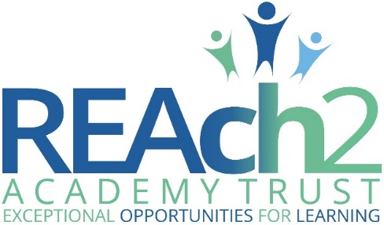
Higher Level Teaching Assistant Application Pack

Letter from Catherine Paine, Chief Executive

Dear Candidate
Thank you for your interest in this role within the REAch2 Academy Trust.
This is a hugely exciting time for our family of schools. The Trust has been recognised by the Department for Education as being well placed to raise standards and achieve excellence for pupils in a growing number of schools nationwide. We are presented with a rare opportunity to make a real difference to the lives and life chances of so many primary school children – many of whom haven’t previously received the educational opportunities they deserve.
The Trust includes schools at all stages of development, from those requiring significant improvement through to existing outstanding schools. As a Trust we are clear about the importance of achieving long term sustainability for our schools. Our vision is to enable individual academies to flourish with real autonomy, whilst also ensuring a strong ethos of support and collaboration across our schools.
Employees within REAch2 belong to a national community of professionals, and benefit from a wide range of networks and development opportunities across the Trust. In time, our best teachers are able to work across schools, develop specialisms and step up to leadership roles within and beyond their own academy. The Trust provides a strong culture of collaboration and support, together with high expectations for staff and pupils alike.
Those we recruit are able to demonstrate that they share our values, are highly motivated to work with colleagues within and beyond their school to continuously develop their skills and pursue professional excellence and are committed to providing the highest standards of teaching for all children. If that is you then we would be delighted to receive your application.
Catherine Paine

Chief Executive, REAch2 Academy Trust
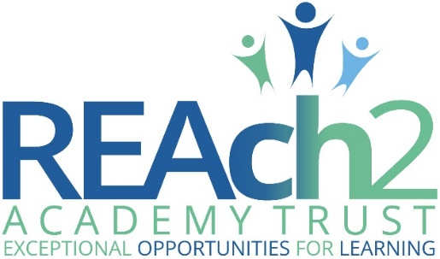

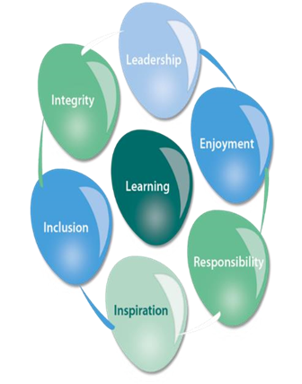
Our Cornerstones and Touchstones
REAch2 is the Cornerstone of the Trust: providing a strong, responsible foundation from which every academy develops and grows. A cornerstone provides a subtle yet paramount role in the construction of a building and ensures that REAch2 is a trustworthy, accountable and inspirational organisation, delivering the best possible learning experience.
REAch2 is defined by the values of excellence, quality, delivery and standards – these features give the Trust its enduring attributes and its inherent reliability.
However, what gives each REAch2 Academy its uniqueness are the Touchstones of the Trust (seen on the right). Just as 500 years ago touchstones were used to test the quality of the gold they marked, so too our touchstones find what is precious and set these things apart. They are used to express the values and ethos of the Trust and describe what the Trust wants to be known for and how it wishes to operate.
With good leadership, we aspire to develop children academically, emotionally, physically and spiritually. We notice talent and spot the ‘possible’ in people as well as the ‘actual’. Developing potential across our Trust becomes a realisation that there is a future worth pursuing for everyone.
Children deserve enjoyment in their learning and the pleasure that comes from absorption in a task and achieving their goals. Providing contexts for learning which are relevant, motivating and engaging, release in children their natural curiosity, fun and determination.
Inspiration breathes energy and intent into our schools: through influential experiences, children can believe that no mountain is too high and that nothing is impossible.
REAch2 serves a wide range of communities across the country and we celebrate the economic, social, cultural and religious diversity that this brings: embracing inclusion ensures that we are a Trust that serves all, believing that everyone can succeed.
We take our responsibility seriously. We act judiciously with control and care. We don’t make excuses, but mindfully answer for our actions and continually seek to make improvements.
REAch2 is a Trust that has a strong moral purpose, our integrity is paramount. Our mission is to change children's lives by providing the very best quality education we can. Through this, children can fulfil their potential, become happy, successful adults and contribute effectively and meaningfully to society. We welcome the fact that all our decisions and actions are open to scrutiny. You can learn more about REAch2 at our website: www.reach2.org

The role – Higher Level Teaching Assistant @ Tymberwood Academy

We are looking for an aspiring Higher Level Teaching Assistant to join our team from September 2022. Tymberwood Academy, part of Reach2 offers a supportive environment and your career development will be encouraged.
Our school is looking for the following qualities
- Passion for teaching
- Hardworking
- Organised
- Team player
You will need to hold a certified qualified HLTA qualification, be enthusiastic and keen to participate in all areas of school life. You will be an integral part of school life supporting students, teaching whole classes and/or groups of pupils. No two days will be the same.
We are looking for someone who has experience in the primary classroom, who is flexible and values working in a team. We are interested in someone who is passionate about teaching and has a really good understanding of how pupils learn. This post if for 35 hours per week, term time only.
To see for yourself everything that Tymberwood has to offer please visit our website or, better yet, come and visit the school to see first-hand.
Any offer of employment for this post will be subject to a satisfactory DBS check and employment checks.
This school is committed to safeguarding and promoting the welfare of children and young people and expects all staff and volunteers to share this commitment.
At Tymberwood Academy, we offer not just a teaching position but an environment that will challenge you, support you and celebrate you on your teaching journey as a lifelong learner. If you believe that you have the attributes necessary to help establish and shape our school please contact the Head Teacher, Sarah Kelley-Day, (via the main office on 01474 361193), for an informal discussion where a warm welcome awaits you.

The application
You are invited to submit an application form to Carol Kerr, School Business Manager – Carol.Kerr@tymberwoodacademy.org.uk

REAch2 Academy Trust have an Equal Opportunities Policy for selection and recruitment. Applicants are requested to complete the Trust’s online Equality & Diversity Monitoring Form separately.

In accordance with our Safeguarding Policy the successful candidate will be required to have an enhanced DBS check.

To arrange an informal discussion please contact the School Office on 01474 361193.

The application process and timetable

Application deadline: | Friday, 30th June 2023 @ Midday
School visits: | Upon request
Interviews: | tbc
Contract details: | Carol.Kerr@tymberwoodacademy.org.uk
Salary: | KR6
Start date: | Asap/September 2023

The candidates selected for interview will be informed after shortlisting and full details of the interview programme will be provided.

Safeguarding, Safer Recruitment and Data Protection

At REAch2 we recognise that those who work in an academy are in a unique position in their care of children. The responsibility for all staff to safeguard pupils and promote their welfare, as stated in Section 175 of the Education Act (2002) is one that is central to our ethos, our policies and our actions. All children are deserving of the highest levels of care and safeguarding, regardless of their individual characteristics or circumstances, and we are committed to applying our policies to ensure effective levels of safeguarding and care are afforded to all our pupils.

We will seek to recruit the best applicant for the job based on the abilities, qualifications, experience as measured against the job description and person specification. The recruitment and selection of staff will be conducted in a professional, timely and responsive manner and in compliance with current employment legislation, and relevant safeguarding legislation and statutory guidance.

All information is stored securely and any information supplied by unsuccessful candidates will be destroyed through a confidential waste system six months after the decision has been communicated, in accordance with our information and records retention policy.

The Trust ensures all applicant data is stored and processed appropriately. For further details on how your information will be managed during the recruitment process please refer to our Privacy Notice for Job Applications.

Job Description

- PURPOSE OF JOB
The Primary focus of the post will be to work under the professional direction of a teacher as part of the professional team to support learning activities for pupils. Within an agreed system of supervision the HLTA would deliver lessons set by or with teachers and/or support pupils undertaking lessons delivered via distance learning or computer aided techniques.
The post holder will be expected to progress pupils’ learning and to assess, record and report on development, progress and attainment as agreed with the teacher.

- PRINCIPAL ACCOUNTABILITIES

- Organise and manage an appropriate learning environment and assist the teacher to plan teaching and learning objectives to ensure pupil progress and development.

- Monitor and evaluate pupil responses to learning activities through a range of assessment and monitoring strategies against pre-determined learning objectives, providing feedback and reports to teachers in order to provide evidence of the range and level of progress and attainment.

- Support the role of parents in pupils’ learning and lead meeting with parents to provide constructive feedback on pupils’ progress to ensure pupils achieve their best results.

- Act as a role model and establish clear framework for discipline in line with established policies, anticipate and manage behaviour in order to promote pupils’ self control and independence to ensure good behaviour and respect for others is maintained.

- Use detailed knowledge and specialist skills to support pupils’ learning, establishing productive working relationships, promoting inclusion and working to support pupils consistently whilst recognising and responding to individual needs. This will ensure equality of opportunity and ensure learning outcomes are achieved for all pupils.

- Understand and comply with policies and procedures relating to child protection, equal opportunities, health, safety, security, confidentiality and data protection, reporting concerns to an appropriate person in order to maintain an safe and secure learning environment.

- Contribute to the overall work/aims of the school and, in liaison with the teacher, establish constructive relationships and communicate with other agencies/professionals, in order to support the achievement and progress of pupils

- Participate in training and other learning activities as required and attend relevant meeting to ensure own continuing professional development.

- NECESSARY EXPERIENCE

- Successful relevant experience of working with children of relevant age within a learning environment.

- Have an HLTA accredited qualification

- Full working knowledge of relevant policies, codes of practice and legislation plus working knowledge and experience of implementing national curriculum and other relevant learning programmes.

- Good understanding of child development with the ability to apply behaviour management policies and strategies which contribute to a purposeful learning environment.

- Be able to work effectively as part of a team and contribute to group planning etc. but also be able to work independently and on own initiative.

- Must be flexible with effective time management skills.

- Be able to work calmly under pressure with the ability to adapt quickly and effectively to changing circumstance/situations.

- Have a creative approach to problem solving and use this to inspire and motivate pupils.

- Must have excellent communications skills in order to build rapport with adults and children, both verbally and in writing

- Must have ability to critically evaluate own performance.

- JOB CONTEXT

Support staff in schools make a strong contribution to pupils’ learning and achievement. Teachers’ professional training, knowledge and experience enable them to take overall responsibility for pupils’ learning. They are not, however, required to take sole responsibility for every aspect of each lesson that is taught. The HLTA’s provide support to teachers and schools allowing qualified teachers to make even more effective use of their time, professional knowledge, skills and understanding. HLTA’s contribute to pupils’ learning and will have a significant impact on pupils’ achievement.

HLTA’s will be expected to work effectively with individual pupils, small groups and whole classes under the direction of a class teacher. They will contribute to, and need to demonstrate skills in, planning, monitoring, assessment and class management. HLTA’s would also be expected to work as part of the school team and contribute to plans to ensure the school meets its aims.
The post holder must work within the relevant policies, codes of practice and legislation reporting any concerns to the relevant person.
The post holder must have excellent communications skills to be able to inform, persuade, inspire and motivate pupils and provide feedback to other professionals and parents as required.

PERSON SPECIFICATION
 | Essential | Desirable
Qualifications | - HLTA status with experience of teaching classes or equivalent.  - To be able to demonstrate levels of Numeracy and Literacy equivalent to GCSE C or higher
Experience | - working in schools for a minimum of 3 years  - teaching whole classes
Knowledge and Understanding | To have knowledge and understanding of:  - HLTA Standards  - Relevant policies, codes of practice and legislation including safeguarding  - Multi agency working  - Behaviour management strategies  - The National Curriculum  - Whole school initiatives and strategies (e.g. Power of Reading, Pie Corbett)  - Assessment procedures in school and make appropriate contributions
Skills | - Demonstrate the HLTA standards  - Be able to support the teacher in planning effective activities for pupils at risk of underachieving;  - develop their knowledge through the evaluation of their own learning needs;  - work independently  - Work well as a part of a team and organise be able to organise other adults in the classroom.  - Calm under pressure and able to adapt to change quickly  - Communicate effectively with parents  - Maintain appropriate professional boundaries with children, parents and staff  - Maintain appropriate levels of confidentiality

