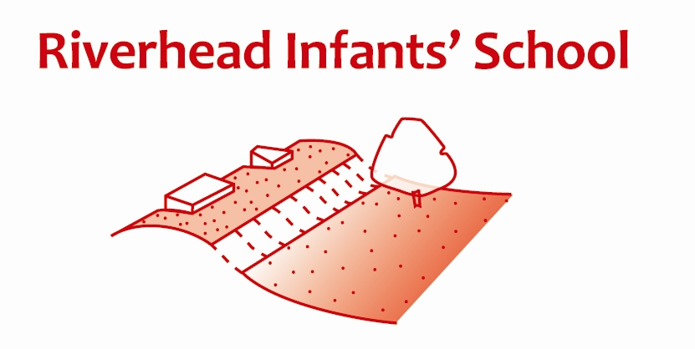
Riverhead Infants’ School

Job Description:

Teaching Assistants

PURPOSE OF JOB
To support the class teacher with their responsibility for the progress, development and achievement of all pupils
PRINCIPAL ACCOUNTABILITIES
- To encourage pupils to develop independent thoughts and actions and to know that it is the process of learning and understanding that is of paramount importance, that is, a piece of work produced by a child using independent thought and initiative is of far greater educational worth than a piece of work produced according to instruction and direction of an adult with little regard for the concepts and skills of the child.
- Support pupils in accessing learning activities as directed by the teacher both indoors and out to enable progress in learning. Use ICT effectively to support learning and communication.
- Be aware of and support the ethos of inclusion to ensure all pupils have equal access to opportunities to learn and develop. To show each child they are valued and that their contribution during learning activities is needed and valued.
- Act as a role model setting high expectations and demonstrating a positive attitude to learning and our roles and responsibilities in school. To be reliable and dependable to all staff and pupils to engender respect and trust.
- Assist teachers with learning activities including assessment, ensuring health and safety and good behaviour of all pupils.
- Ensure the maintenance of a clean, orderly and safe working environment making sure that equipment/resources/materials are set out on time and used safely to enable pupils to meet their learning targets.
- Provide support (e.g. photocopying, resources) and undertake basic record keeping in respect of pupil learning, behaviour management, child protection etc. as directed in order to support the specific learning programmes set for each child and their wellbeing.
- Be aware of and comply with policies and procedures relating to safeguarding, health, safety, security and confidentiality reporting all concerns to an appropriate person to ensure pupils’ wellbeing.
- To work mindfully to maintain own physical and emotional health.
- Contribute to the overall ethos of the school and participate in the development and implementation of the School Improvement Plan.
- To work collaboratively as a team member ensuring effective consideration of colleagues and including effective sharing of information.

- To work collaboratively as part of the wider team with parents/carers and with other professionals in education and health.

- To be a pro-active and responsible member of the Riverhead Infants’ School community.
- To be open and willing to learning new skills and to undertake training and other learning activities and attend relevant meetings and training as required to ensure own continuing professional development.
- Attend to pupils personal care needs and assist with the organisation of refreshments and mealtimes (this may include feeding pupils by gastric tube following appropriate training) to ensure pupils’ wellbeing and health and safety.
- Implement behaviour management programmes for pupils with severe learning and/or emotional problems to ensure pupils’ wellbeing, health, safety and learning needs are met.
- Provide support for the class teacher and colleagues in the manual handling and/or physical restraint of pupils to ensure pupils’ wellbeing, health and safety is maintained, and assist with the development of hygiene, toilet training and general dressing programmes

NECESSARY EXPERIENCE

- Good standard of general education (i.e. NVQ level 2 or equivalent) together with good level of Maths and English.

SCOPE FOR IMPACT

Support staff in schools make a strong contribution to pupils’ learning and progress. TAs provide support to teachers and schools allowing qualified teachers to make even more effective use of their time, professional knowledge, skills and understanding. TAs contribute to pupils’ learning and will have a significant impact on pupils’ achievement and well-being.

JOB CONTEXT

TAs will be expected to work effectively with individual pupils and/or small groups under the direction and supervision of a class teacher. They will contribute to, and need to demonstrate skills in, monitoring, assessment and class management. TAs will be expected to participate in playtime and lunchtime duties to ensure the wellbeing and safety of the pupils. They would be encouraged to share particular skills and interests of their own to the benefit of the pupils. TAs would also be expected to work as part of the school team and contribute to plans to ensure the school meets its aims.
The post holder must work within the relevant policies, codes of practice and legislation reporting any concerns to the relevant person.
The post holder must have good communications skills to be able to inform, persuade, inspire and motivate pupils and provide feedback to other professionals and parents as required.

Signed:………………………………………………… Teaching Assistant

Print Name………………………………………………Date:………………....

Signed:………………………………………………… .Appraiser

Print Name………………………………………………Date:………………….

