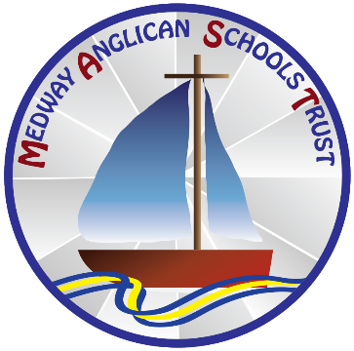

Recruitment of Ex-Offenders Policy
As an organisation assessing applicants’ suitability for positions which are included in the Rehabilitation of Offenders Act 1974 (Exceptions) Order using criminal record checks processed through the Disclosure and Barring Service (DBS). Medway Anglican Schools Trust complies fully with the code of practice and undertakes to treat all applicants for positions fairly.

Medway Anglican Schools Trust undertakes not to discriminate unfairly against any subject of a criminal record check based on a conviction or other information revealed.

Medway Anglican Schools Trust can only ask an individual to provide details of convictions and cautions that we are legally entitled to know about. Where a DBS certificate at either standard or enhanced level can legally be requested (where the position is one that is included in the Rehabilitation of Offenders Act 1974 (Exceptions) Order 1975 as amended, and where appropriate Police Act Regulations as amended).

Medway Anglican Schools Trust can only ask an individual about convictions and cautions that are not protected.

Medway Anglican Schools Trust is committed to the fair treatment of its staff, potential staff, or users of its services, regardless of race, gender, religion, sexual orientation, responsibilities for dependants, age, physical/mental disability, or offending background.

Medway Anglican Schools Trust has a written this policy on the recruitment of ex-offenders, which is made available to all DBS applicants at the start of the recruitment process.

Medway Anglican Schools Trust actively promotes equality of opportunity for all with the right mix of talent, skills, and potential and welcomes applications from a wide range of candidates, including those with criminal records.

Medway Anglican Schools Trust select all candidates for interview based on their skills, qualifications, and experience.

An application for a criminal record check is only submitted to DBS after a thorough risk assessment has indicated that one is both proportionate and relevant to the position concerned. For those positions where a criminal record check is identified as necessary, all application forms, job adverts, and recruitment briefs will contain a statement that an application for a DBS certificate will be submitted in the event of the individual being offered the position.

Medway Anglican Schools Trust ensures that all those who are involved in the recruitment process have been suitably trained to identify and assess the relevance and circumstances of offences.

Medway Anglican Schools Trust also ensures that they have received appropriate guidance and training in the relevant legislation relating to the employment of ex-offenders, e.g., the Rehabilitation of Offenders Act 1974

At interview, or in a separate discussion, the Medway Anglican Schools Trust ensures that an open and measured discussion takes place about any offences or other matter that might be relevant to the position. Failure to reveal information that is directly relevant to the position sought could lead to withdrawal of an offer of employment.

Medway Anglican Schools Trust makes every subject of a criminal record check submitted to DBS aware of the existence of the code of practice and makes a copy available on request.

Medway Anglican Schools Trust undertakes to discuss any matter revealed on a DBS certificate with the individual seeking the position before withdrawing a conditional offer of employment.

Policy Agreed: 13th January 2022

Policy Review Date: September 2024

