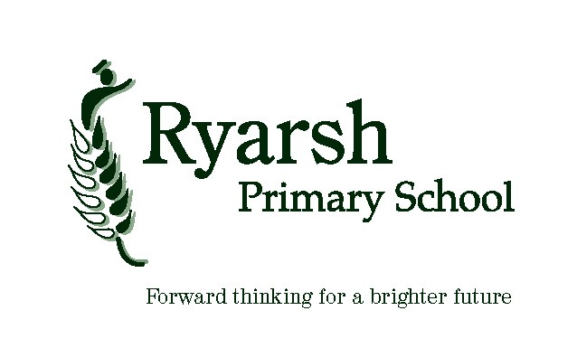
Ryarsh Primary School
Classroom Teacher – Person Specification

Essential | Desirable
Qualifications
- Qualified Teacher Status
- Degree or equivalent
- Evidence of commitment to own professional
development

Experience
- Evidence of highly effective teaching | - Experience of subject leadership
Teaching and Learning
- Is an excellent classroom practitioner or has the capability to be an excellent classroom practitioner.  - Has high expectations of attainment and learning behaviour  - Uses assessment approaches to gather information and adapt the provision based on the feedback received  - Builds excellent relationships with children that underpin strong learning behaviours  - Plans exciting and structured learning experiences to develop and deepen thinking  - Uses differentiation so that every child can succeed and is challenged appropriately | - Has a strong understanding of pedagogy through up to date education research
Communication Skills
- Has ability to communicate clearly and take into account views of others
- Can effectively communicate to a range of audiences
- Has shown an ability to work alongside colleagues
- Can adapt interpersonal style to suit different people or situations
Personal Attributes
- Has the capacity to reflect and learn
- Is compassionate, energetic and enthusiastic
- Demonstrates resilience in a range of situations
- Adapts to changing circumstances
- Prioritises and manages time, to achieve a work-life balance.
- Builds strong relationships with all members of the school community

School Ethos
- Has the ability & commitment to develop and maintain the established ethos of the school in partnership with the staff | - Has the willingness to get actively involved in school events within and beyond the classroom

