Brockhill Park Performing Arts College
Sandling Road
Saltwood
Hythe, Kent.
CT21 4HL

MFL Teacher
Salary: MPS/UPS

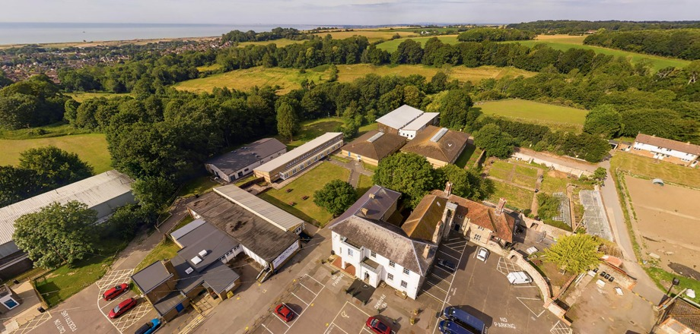
April 2023 start

Job Description

MFL Teacher
Salary: MPS/UPS (we will match current pay grades)
Full Time Position
April 2023

We are seeking to appoint an inspiring and highly motivated teacher of MFL with French & or German to join our forward thinking and thriving department.

The applicant should be an excellent practitioner, keen to ensure the highest standards and contribute towards the success of the department. Have the knowledge and ambition to teach across a full age and ability range. Be enthusiastic, resourceful and an excellent communicator.

Main Duties
- Deliver a well planned lesson, that engages all students and rapidly progresses their development and subject knowledge
- Setting and assessing homework that further strengthens student knowledge and development
- Set high aspirations for students
- Adapt teaching to support the needs and strengths of all students
- Have a strong knowledge of the subject
- Be able to implement rules and behaviour policies to ensure a productive and safe learning environment
- Set high standards for expected behaviour
- Challenge students learning
- Professional development – use feedback and advice from colleagues to improve performance
- Develop strong professional relationships with colleagues
- Effective communication with parents, carers regarding student development and well-being

Brockhill Park is an 11-19 academy with Performing Arts and Rural Dimension status and supports its own working farm. It is a popular school of 1300+ students situated in rural surroundings on the edge of the Cinque Ports of Hythe.

It is our purpose to develop a creative thinking culture, which is inclusive, innovative and vocational supported by the arts and rural dimension.

We want to:
Enable the future of every student and develop the capacity for lifelong learning. Build and sustain a strong safe learning community. Foster personalisation through creative and cultural learning. Secure sustainability and build capacity.

Applications are welcome from newly qualified teachers as well as those with previous experience.

This is a friendly place to work where all members of staff are valued and students are proud of their school. Career development opportunities are well supported alongside a strong CPD programme.

Brockhill Park is committed to promoting the welfare and safety of children and young people and expects all staff to share this commitment. The appointment is subject to an enhanced disclosure application to the Criminal Records Bureau plus verification of the right to work in the UK and positive references.

Further information about the school is available on the website: www.brockhill.kent.sch.uk
Please feel free to contact the school for further information or to speak with the Subject Leader.

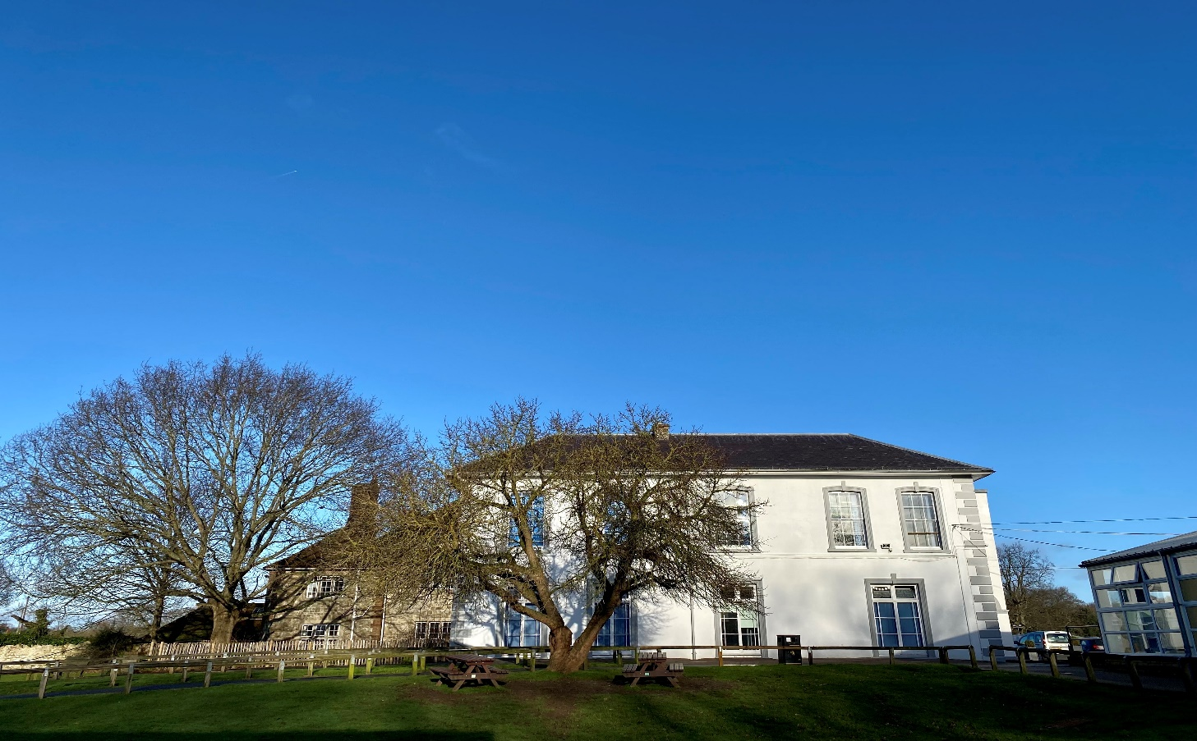

Personal Specification

AREA | ESSENTIAL | DESIRABLE
Education & Qualifications | - Good Degree & Teaching Qualification  - Be able to demonstrate professional development relevant to the role
Experience & Skills | - Ability to lead your own professional development  - Experience of teaching in a secondary setting  - The ability to demonstrate good classroom practices  - Be able to demonstrate good understanding of assessment processes and how to use these to support planning and improve student attainment | - The ability or interest to lead extra curricular activities
Knowledge | - Excellent communication and interpersonal skills, including written, oral and presentation  - Knowledge of current curriculum development in your subject  - The ability to deliver the curriculum to a range of students with varying needs and ensure they are engaged  - To be able to interpret data  - Ensure effective behaviour management and adhere to the school policies  - Helping support both staff and students in maintaining consistent high standards
Personal | - Good interpersonal skills  - Have fresh and positive approach to delivering education  - The ability to work hard and meet deadlines under pressure  - Reliable  - Show commitment to personal development  - Be enthusiastic and resourceful  - Demonstrate the ability to work well using their own initiative as well as working well as part of a team

