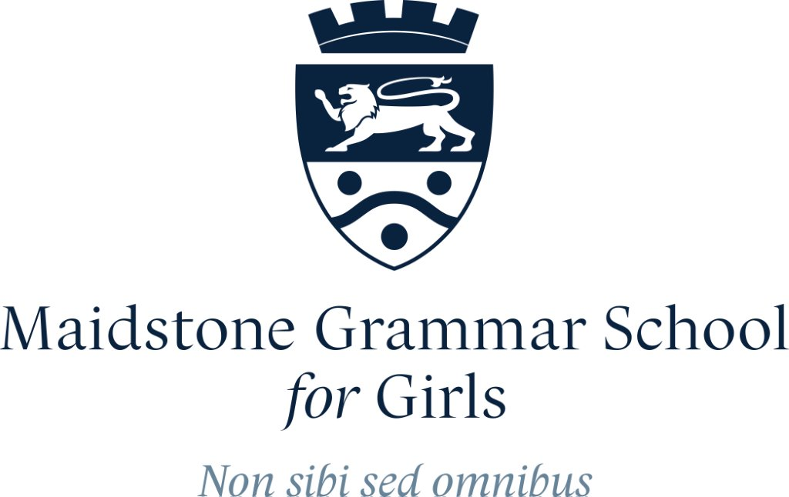

Head of Business Studies & Economics
TLR 2B £5,019 pa

Full-time Permanent MPS/UPS Required from September 2023

We are looking to appoint a creative, enthusiastic and inspiring Head of Business Studies and Economics to lead this important area of our curriculum from September. This department encompasses A Level Business Studies and A Level Economics. Business Studies and Economics are popular subjects with our A level students. Applicants need to be able to teach both Business Studies and Economics to able, creative and motivated students and have a passion for these subjects. This is an excellent opportunity for the right person to join this outstanding school.

We welcome applications from candidates who can demonstrate:

- a passion for teaching Business Studies and Economics
- commitment to promoting high quality teaching and learning within this department
- ability to promote Business Studies and Economics across the curriculum
- experience of teaching both Business Studies and Economics to A level standard would be an advantage.

Maidstone Grammar School for Girls is a very successful selective girls’ school of 1220 students with a mixed sixth form of approximately 340. Since July 2019 we have been appointed by the Department for Education as a Computer Hub in recognition of the expertise the school has evidenced in Computing Education and will take a lead in training teachers across the south east in the delivery of Computing. The post offers the opportunity to work with intellectually able young people in a supportive and friendly environment. Staff benefits include strong support for professional development and healthcare scheme.

“Maidstone Grammar School for Girls is an outstanding school” (Ofsted)

Full details and an application pack are available from the school’s website https://www.mggs.org/joining-us/join-our-team/vacancies/

Applicants should complete our application form and email, along with a covering letter, to the Headteacher’s PA. Applicants are strongly encouraged to also complete our Equal Opportunities & Recruitment Monitoring Form. If you require any additional information please contact Ms Starns, PA to the Headteacher via email: mstarns@mggs.org.

Applications welcomed immediately

Applications will be considered in the order in which they are received. Suitable candidates may be interviewed before the closing date and Maidstone Grammar School for Girls reserves the right to withdraw the position if an early appointment is made.

Closing Date: 8am on 22nd February 2023

Interviews: 27th February 2023

Our School and all its personnel are committed to safeguarding and promoting the welfare of the children. This post is subject to an Enhanced Disclosure Application to the Disclosure and Barring Service.

The post is exempt from section 4 (2) of the Rehabilitation of Offenders Act (ROA) 1974. The amendments to the ROA 1974 (Exceptions Order 1975, (2013 and 2020)). It is not, therefore, in any way contrary to the Act to reveal any information concerning convictions which would otherwise be considered as “spent” in relation to the applicant’s suitability for employment. Any such information will be kept in strict confidence and only used in consideration of the suitability of the applicant for such a position where such an exemption is appropriate.

A forward-thinking community with a tradition of excellence

