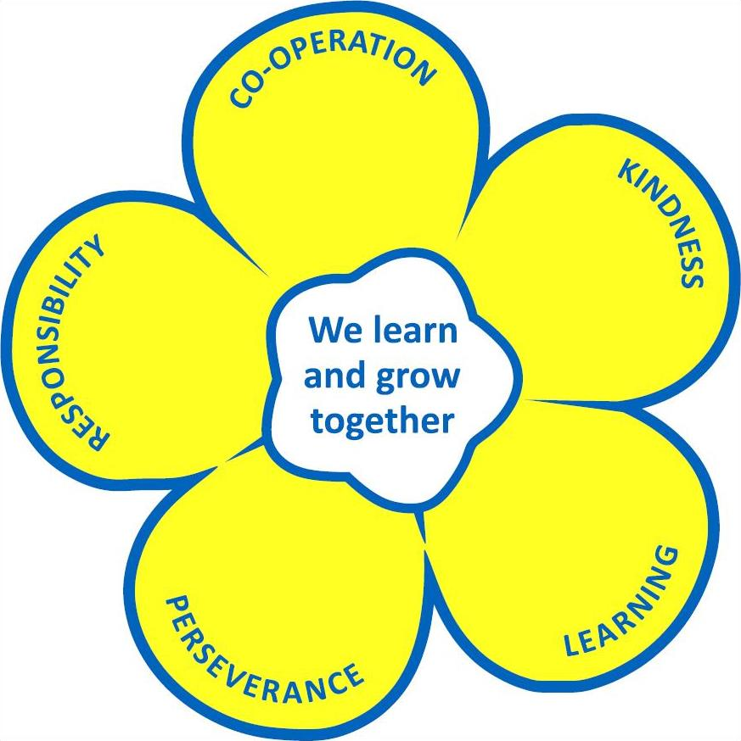
Herne Bay Infant School & Seashells Nursery

Job Description

SCHOOL: HERNE BAY INFANT SCHOOL

POST: MIDDAY MEALS SUPERVISOR

RESPONSIBLE TO: Deputy Headteacher

LIAISES WITH: Class Teacher/Teaching Assistants

Herne Bay Infant School is committed to safeguarding and promoting the welfare of children and young people and expects all staff and volunteers to share this commitment. The post is subject to an enhanced Disclosure application to the Disclosure Barring Service and ISA Registration, plus verification of the right to work in the UK.

Main Purpose of Job:

To assist in the support and inclusion of all children in Herne Bay Infant School.

Support for pupils:

- Support for all pupils with whom the Midday Meals Supervisor comes into contact.
- Ensuring that sufficient resources are available to children to support their positive play experiences.
- Encouraging children to engage in group and team games when appropriate.
- Teaching children new games, skills and songs whenever possible.
- Supporting children who may be experiencing problems or exhibiting challenging behaviour, to enable them to have a successful lunch time.
- If supporting one particular child to have regard for the principle of inclusion that a child who has difficulties should be helped to work in the company of other children.
- Attending to the physical care of children eg. assisting with first aid and toilet supervision.
- Having an awareness of the well-being of the children.
- Supervising and supporting children to eat their lunch and during other outside activities.

Support for the school:

- Liaising with other staff as and when required.
- Translating school policies into practice.
- Furthering the ethos of the school.
- Attending further training, including staff development days (when relevant) and reporting back to other staff.

Midday Supervisory Assistant Person Specification
Essential:
Experience of supervising children as a parent or carer
Knowledge and understanding of managing behaviour of groups of children
Ability to work as part of a group
Ability to individually inspire trust and confidence in children
Ability to encourage and promote high standards of pupil behaviour at all times
Ability to observe the boundaries of the role and respect confidential information
Able to initiate games and activities appropriate to the age of the children
Ability to relate to children on their level
Ability to remain calm in a crisis
Personal Characteristics and wider contribution :
Calm under pressure
Empathetic
Well - organised
Able to communicate with staff and children
Creative
Resourceful
Tolerant
Desirable:
Current First Aid Qualification
Additional experience of working with groups of children on a voluntary or paid basis
Knowledge & understanding of child development & social interaction
Knowledge & understanding of the value of constructive play opportunities
Ability to communicate effectively (both orally & in writing) to an appropriate standard
Ability to recognize behaviour giving cause for concern & inform teaching staff
Ability to teach play activities to other Midday Supervisors
Able to examine systems critically, & suggest ways of improving efficiency

