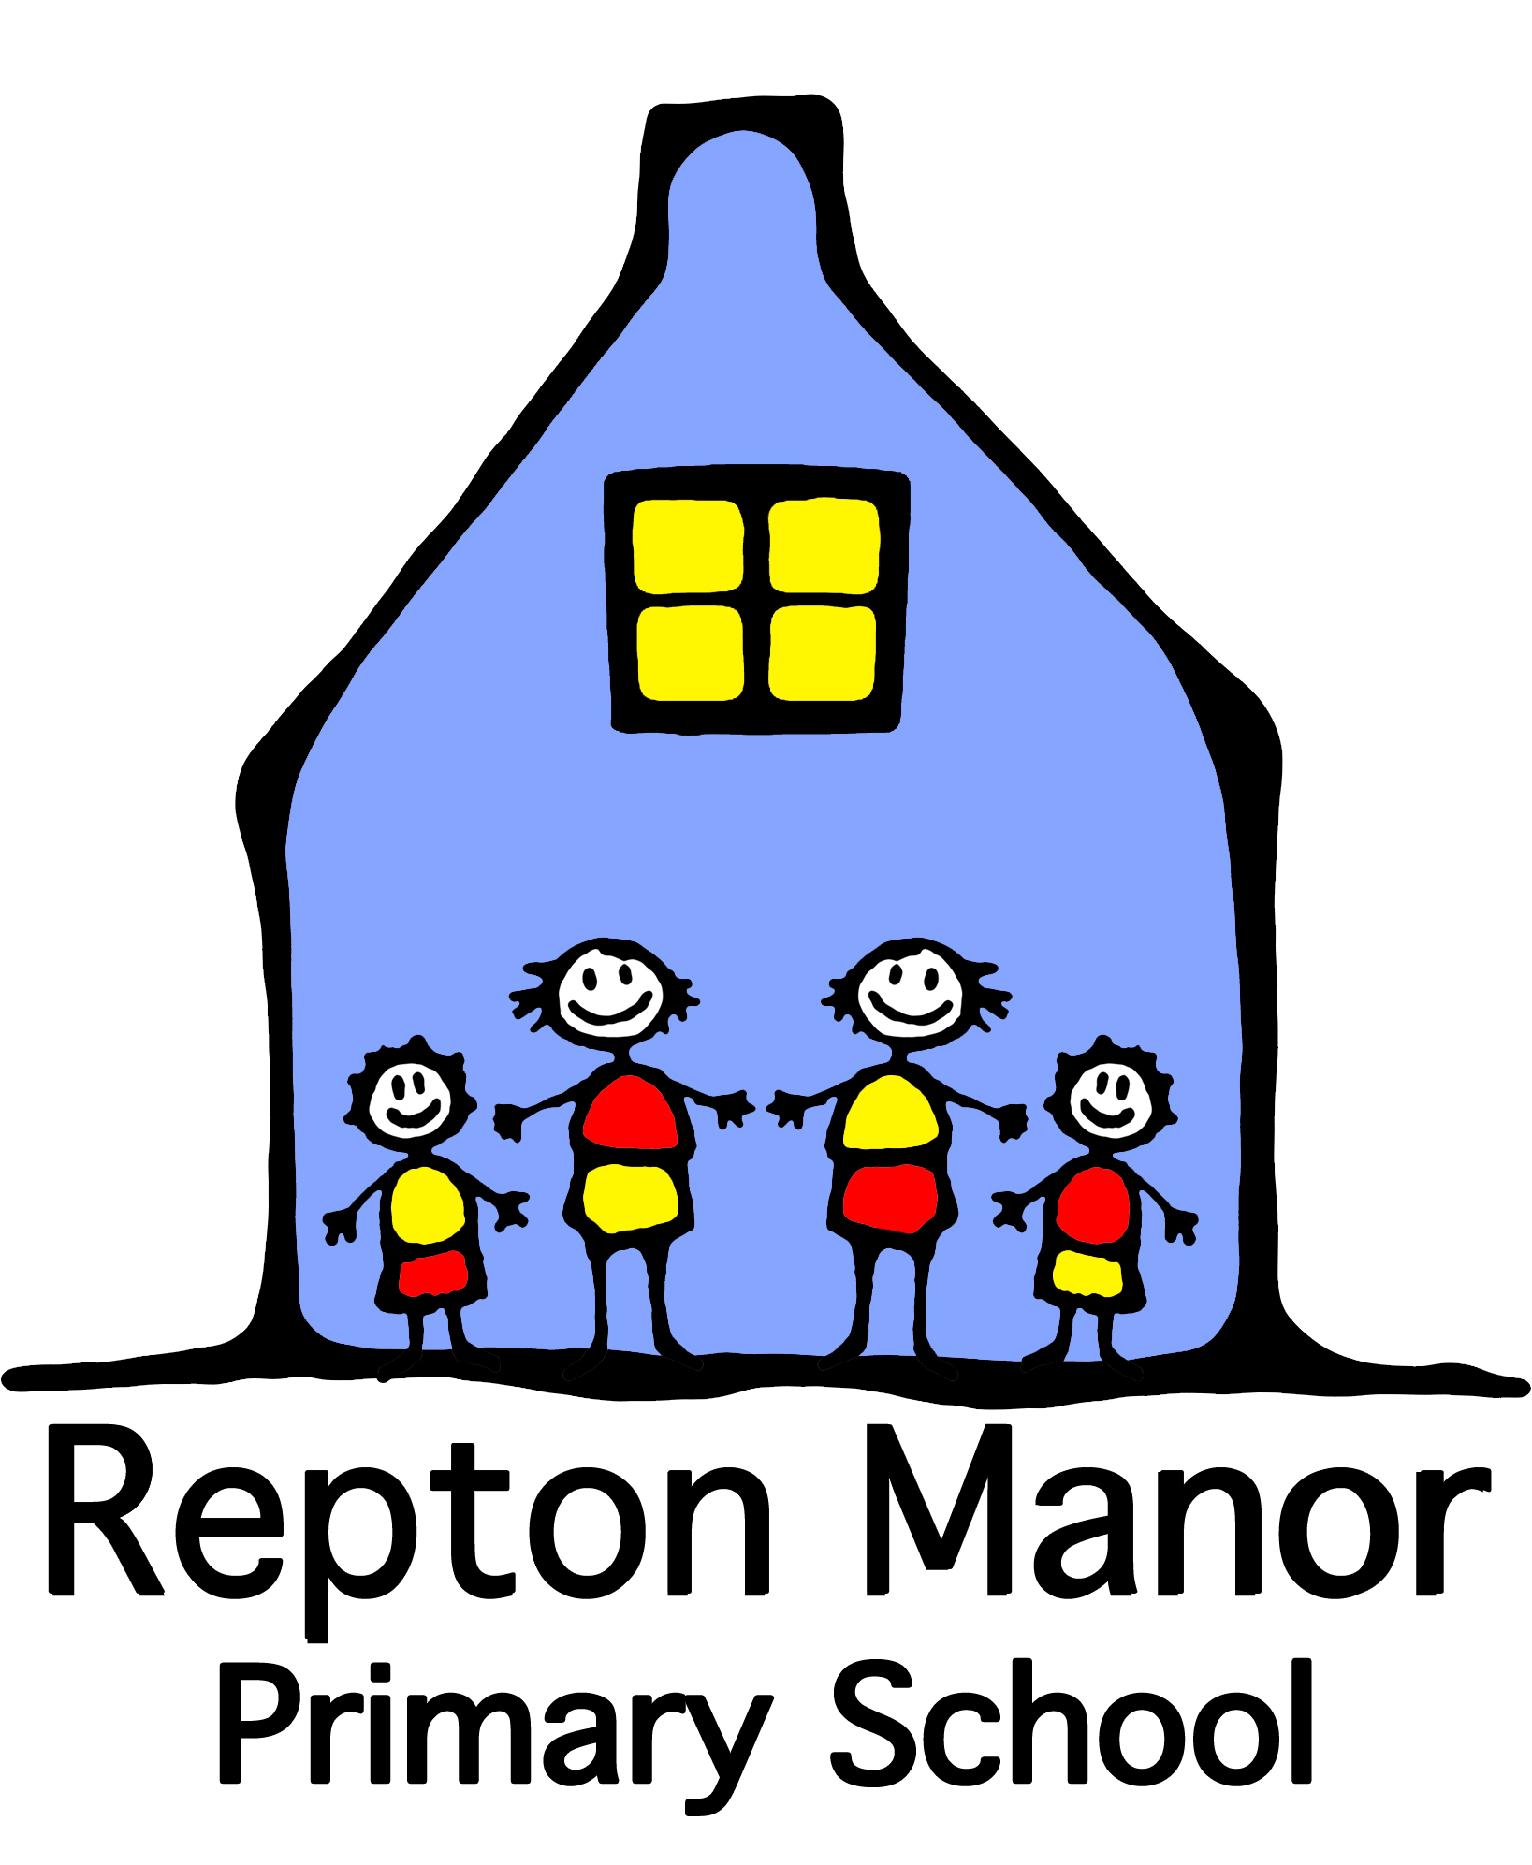

Lightyear Federation
Caring, Dreaming, Thinking Bigger

Job Description: Natural World Teacher

Schools: | Greatstone Primary School / Repton Manor Primary School
Status: | Permanent (FTE)
Salary: | MPS
Responsible to: | Heads of School
Date: | January 23

Purpose of the Job:

To stimulate awe and wonder of the natural world by providing unique and specialist teaching and learning opportunities for the children and staff of the Lightyear Federation. To lead the development of the curriculum assessment, planning, delivery and impact on children’s understanding of the natural world (local school environments developed on both sites and using the local community environments) including horticulture, agriculture, natural habitats, wildlife, natural sciences in all-year round outside learning – directly impacting on standards and achievement of children across the curriculum, including the core subjects.

Key Duties and Responsibilities:

- Contribute to the creation and implementation of outdoor teaching and learning of the natural world.
- Ensure the safe and engaging implementation of outdoor teaching and learning of the natural world.
- To champion, demonstrate and deliver the impact of natural world learning on pupil achievement in all curriculum areas, including core subjects and personal development.
- To ensure the inclusion and engagement of all children in the natural world and outside learning.
- Develop, monitor, evaluate and review teaching and learning practices and plans for outside learning and natural world teaching.
- Support and deliver to the Lightyear Federation staff and children, the planning, teaching, assessing, training and reporting of natural world teaching and outdoor learning embedded in the curriculums.
- Provide extended school opportunities for children and the community, in natural world teaching and learning.

Teaching and Learning

The Natural World Teacher works with the Heads of School to create and maintain a culture and environment that promotes and secures ambitious and high quality teaching, effective outdoor learning, high standards of achievement in related areas of learning and good behaviour.

- Take a lead role in overall outdoor curriculum design, coordination, teaching and assessment.
- To meet the national standards for teachers through the teaching and learning of the natural world through outdoor teaching and learning – all year round.
- Provide clear educational direction for the development of outdoor learning embedded in the Lightyear Federation schools’ curriculums and teaching.
- Contribute to the establishment and maintenance of related policies, procedures, coordination and communication which promote effective professional practice and define curriculum content.
- Ensure effective monitoring, recording and evaluation of the quality of learning and standards of achievement of all pupils.
- Establish a learning culture which promotes innovation and creativity in delivery of the natural world curriculum through outdoor learning and monitor and evaluate its implementation.
- Promote and maintain an effective partnership with staff and parents to improve children’s achievement and personal and social development through natural world education as an integral part of the curriculum in both schools.

Accountabilities

- To ensure a proportionate division of teaching time and impact between the schools that make up the Lightyear Federation.
- Take an active role within the teaching team of the Lightyear Federation schools, driving forward school and Lightyear Federation improvement priorities related to the natural world teacher role.
- To be an exemplar, role model and leader of natural world and outdoor learning.
- To manage an allocated budget in line with relevant financial policies and procedures, associated to the role, and liaise with the site staff and Head of School, ensuring best value principles are applied.
- Research and apply for relevant and available grants or funding opportunities to enable development of natural world teaching or outdoor learning.
- To demonstrate a thorough, up to date knowledge of current educational initiatives and Government policy and take an active role in ensuring their implementation within the teaching of the natural world.
- To ensure the ambitious and exciting approaches to teaching and learning are safe for children and staff meeting health and safety legislation standards.
- To ensure the proper planning, resourcing maintaining of the specific area of school site, related resources, materials and animal welfare standards.
- To promote the ethos of the Lightyear Federation and it’s standing in the wider community.
- To develop procedures to record, communicate and monitor standards of learning outcomes for natural world related studies and share these with parents, staff and leaders.

Footnote: This job description is provided to assist the job holder to know what his/her main duties are. It may be amended from time to time without change to the level of responsibility appropriate to the grade of post.
Lightyear Federation
Person Specification: Deputy Headteacher

 | CRITERIA
QUALIFICATIONS | Teaching Qualification, including QTS
EXPERIENCE | Previous experience of teaching a diverse range of children and age ranges.  Experience of demonstrable positive impact on the teaching and learning of children aged 2-11yrs old.  Ensuring the creative, sustainable approaches to teaching and learning with tangible good progress for children.  Experience of building strong relationships within school communities.
SKILLS AND ABILITIES | Ability to enthuse, ensure support and commitment to the related Federation and vision and values.  The desire to work outside in all seasons, promoting the benefits and encouraging/supporting others to do so.  Ability to liaise with various stakeholders and lead and manage the implementation of natural world learning within school communities and curriculums.  The competency to record, review and dynamically risk assess activities led for children in the specialist area updating and informing the site manager and Head of School.  Organisational abilities and an accurate detailed understanding of delivering training, teaching, assessing, planning and impact measures.  Ability to facilitate a nurturing and inclusive approach to all staff, children and parents.  Good inter-personal skills including developing confidence in high quality teaching and learning in others.  High level behaviour management skills – ensuring the inclusion of all pupils in activities and liaising with staff regarding SEND/pastoral needs of individual and groups of children.
KNOWLEDGE | Sound knowledge and understanding of educational pedagogy and national standards in curriculum expectations.  Knowledge of necessary budgetary principles in the planning, delivery and sustaining of related projects and funding.  Detailed knowledge of natural world studies and related curriculum standards.  Demonstrate an understanding of professional standards, safeguarding / child protection procedures, risk assessment and health and safety legislation and standards related to promoted activities.

