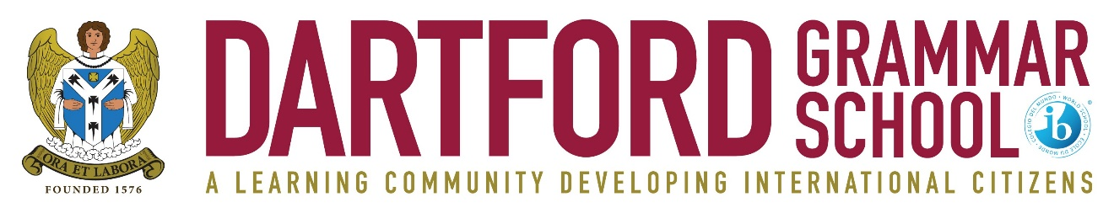

FULL TIME TEACHER OF CHINESE
MPS/UPS + LFA
(part time would be considered)

Required for April 2023

An enthusiastic and committed Teacher of Chinese in a high performing IB World School offering excellence within the state sector.

The governors are looking for a dynamic and collaborative individual to play a key role in the strategic development of the school (notably its financial and capital resources), to oversee its day-to-day organisation, and lead the school’s considerable co-curricular programme.

Dartford Grammar School is one of the highest performing schools nationally at Key Stage 4 and Key Stage 5, with excellent facilities, designated as ’outstandingly successful’ in successive national and international inspections.

We are keen to hear from you if you are:
• an excellent classroom practitioner
• committed to raising achievement and transforming learning
• well-organised, proactive and able to work effectively as part of a team
- excited at the prospect of teaching bright, hard-working students

We can offer you:
• the opportunity to inspire highly able and well-motivated students to fulfil and exceed their potential
• a dynamic and supportive working environment
• a well-established Induction Programme
• opportunities for professional development

Please use the contact details below if you would like the opportunity to tour the school or to meet the Headteacher before making an application.

For further details and an application pack please contact the school - telephone: 01322 223039; fax: 01322 291426; e-mail: mbexley@dartfordgrammarschool.org.uk

Please return a completed application form, to the Head, Mr Julian Metcalf, Dartford Grammar School, West Hill, Dartford, Kent DA1 2HW.
Closing date: Friday 2nd December 2022
Interview date: TBC
(The school may interview early in the case of an exceptional candidate)

Dartford Grammar School is a selective secondary academy for boys, which admits girls to its sixth form. There are six forms of entry to Year 7, and all of the students joining the school are from the top 25% of the ability range. The current roll is 1,516, including 598 in the sixth form.

The school is committed to safeguarding and promoting the welfare of children and young people and expects all staff to share this commitment. An enhanced DBS check is required for all successful applicants.

