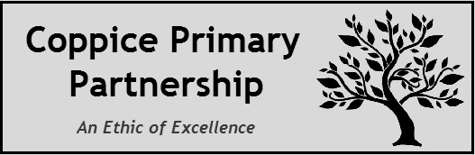
Receptionist/Administrative Assistant

Person Specification

The following outlines the criteria for this post. Applicants who have a disability and who meet the criteria will be shortlisted.

Applicants should describe in their application how they meet these criteria.

 | Essential | Desirable
Qualifications | - Good general education/NVQ in admin or other relevant qualification  - GCSE English & Maths 4-9 or equivalent | - Word processing qualification or equivalent  - Qualified First Aider (or prepared to be trained as such)  - SIMS experience (or prepared to attend training)
Experience | - Previous admin experience  - Previous customer service experience | - Previous experience of working in a school environment
Skills and Abilities | - Attention to detail and methodical approach to work  - Organised  - Good communication skills  - Good record keeping skills  - Highly computer literate  - Confidentiality | - A working knowledge of SIMS  - Child Protection and safeguarding understanding  - Knowledge of Health & Safety Regulations  - Knowledge of school procedures
Personal Qualities | - Team Player  - Friendly and helpful  - Patient and tolerant  - Positive and flexible attitude to work  - Ability to form and maintain appropriate relationships with children and young people  - To be committed to continual professional development

