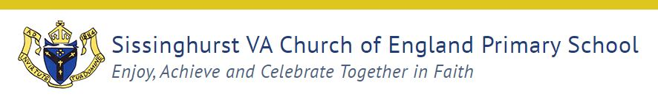
Job Description Meals Supervisor
Name:

Grade: Kent Range 3
Responsible to: Line Manager
Purpose of the Job:
Supervise the pupils during the mealtime period to minimise any disruption, ensure their
wellbeing and maintain their safety. To support pupils in developing positive friendships
and make healthy choices.

Key duties and responsibilities:
1. Put out tables (where applicable) and set with cutlery and beakers in time for the
mealtime period to ensure there are sufficient settings for the number of pupils eating
that day.

2. Ensure pupils enter the dining room in a safe and orderly fashion and behave
appropriately when queuing for their meal in order to maintain safety and wellbeing
of all pupils.

3. Ensure pupils eating meals are seated in an orderly fashion to maintain safety and
wellbeing of the pupils.

(This may include checking that pupils have a drink and that sufficient amounts of
their meal have been eaten).

4. Clean and tidy equipment at the end of each session.

5. Assist the pupils, as necessary, during the meal break to ensure their wellbeing.
(This may include providing them with a drink, helping with spillages, cutting up food
and caring for pupils’ personal needs).

6. Ensure plates, etc., are cleared from tables in an appropriate manner to maintain a
clean and tidy environment and to free up space for any further sittings where
applicable.

7. Ensure once meals are finished that the dining area is wiped down, etc., and is left in
a clean and tidy manner to maintain a clean and tidy environment.

8. Assist in collecting pupils from their collection point and escort to hall/classroom or
patrol and supervise school areas used by the pupils at mealtimes, to ensure safety
and appropriate behaviour is observed, as applicable.
9. Operate, where applicable, a first aid service, during the mealtime to deal with any
accidents that occur safely and quickly.

10. Support the school’s behaviour system in your approach to incidents and make sure significant incidents are communicated to the appropriate member of staff.

11. Support pupils to resolve friendship issues at playtime through a calm, nonjudgmental approach.
Footnote: This job description is provided to assist the job holder to know what his/her main duties are. It may be amended from time to time without change to the level of responsibility appropriate to
the grade of post.
Kent County Council

Person Specification: Mid Day Supervisor
The following outlines the criteria for this post. Applicants who have a disability and who meet
the criteria will be shortlisted.
Applicants should describe in their application how they meet these criteria.

CRITERIA
QUALIFICATIONS
You will not need previous specific experience or qualifications.
Recent school leaves will have evidence of basic educational
achievements or qualifications.
Safeguarding training will need to be undertaken annuallyfacilitated by the school.
First Aid qualification would be an advantage.
Team teach (positive handling) would be an advantage.

EXPERIENCE
Previous experience of working with children would be an
advantage

SKILLS AND ABILITIES
Ability to Communicate with pupils during midday breaks
e.g., to encourage healthy meal selection, oversee play
activities.
Coaching skills to support pupil conflict and enable them to
come to a resolve.
Ability to recognise and deal with emergency situations.
May require knowledge if responsible for the safe use of
playtime equipment.

KNOWLEDGE
Requires knowledge of school procedures for supervision of
pupils during midday break and lunchtime activities where applicable

