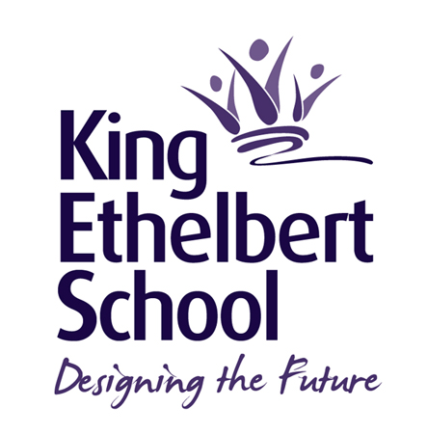

Science Department

The department currently comprises a Head of Department, a second in charge of Science and seven others who teach across the age and ability range, with a science lab technician supporting the department.

Students are taught in mixed ability tutor groups Key Stage 3 and then set for Key Stage 4. Currently at Key Stage 3 students broadly follow “Activate” and practical work forms an integral part of this, promoting students’ investigation and problem solving skills. At Key Stage 4 most students follow the new AQA GCSE Combined Science Trilogy with the introduction of AQA separate sciences in 2021. The Science Department additionally runs level 3 BTEC Applied Science at Key Stage 5 as part of the IBCP. IB Biology and IB Environmental Systems and Societies also run in Key Stage 5.

The school was part of Wave 3 Building Schools for the Future programme and the Science department is in newly refurbished buildings, with 5 fully integrated, purpose built science laboratories including one large ‘master lab’. Additionally a well equipped prep room run by our brilliant science technician means that learning is routinely underpinned with regular practical work. All rooms have data projectors and interactive whiteboards and drop down screens to mirror the white board. A range of software and teaching packages are used to support teaching, learning and independent study. There are banks of bookable laptops available for use within lessons.

We, therefore, seek to appoint an innovative, dynamic and capable practitioner who will support the head of department in leading the subject. This is a fantastic opportunity to work in an excellent school at the cutting edge of educational developments gaining a national reputation for its success. A comprehensive induction programme is provided into the work of King Ethelbert School and a specific mentoring and guidance programme operates for all new entrants. Ofsted have recognised that guidance and support given by staff for students is outstanding. It is expected that all potential members of staff will have a passion and a commitment to each child achieving their personal best.

King Ethelbert School is committed to safeguarding and promoting the welfare of children. This position is therefore subject to an enhanced Disclosure and Barring Service application.

The successful candidate may also hold a pastoral responsibility as a tutor within a year system.

June 2022

