

Nursery Teacher



**Welcome to**

The Howard Academy Trust

As a Trust, we currently comprise of Medway secondary and primary schools. We have future growth plans as a Multi Academy Trust with major projects taking place across the organisation.

Our overarching aim and vision is for our member schools to deliver an outstanding education for children and young people. We endeavour to ensure that all our students have access to the highest standards of teaching, resources and opportunities. The Trust’s role is to oversee the leadership and vision of member schools and to develop effective and supportive partnerships between them. We have a firm belief within the Trust that every child should have access to at least a good education.

We are proud that every academy inspected since joining our Trust has remained as a Good school. Temple Mill Primary School joined the Trust as a sponsored academy in December 2015 and has moved from Special Measures to a Good school. Our schools serve their own community and each has a unique identity. Being part of this Multi Academy Trust has already provided member schools with practical benefits. We want communities to be proud of their local THAT school and we are determined to make it the first choice for all families.

As Chief Executive, I am enormously proud of our schools and of the leaders, governors, teachers and support staff who every day ensure our pupils enjoy and make good progress in their learning.

*Owen McColgan*

**Chief Executive**

The Howard Academy Trust

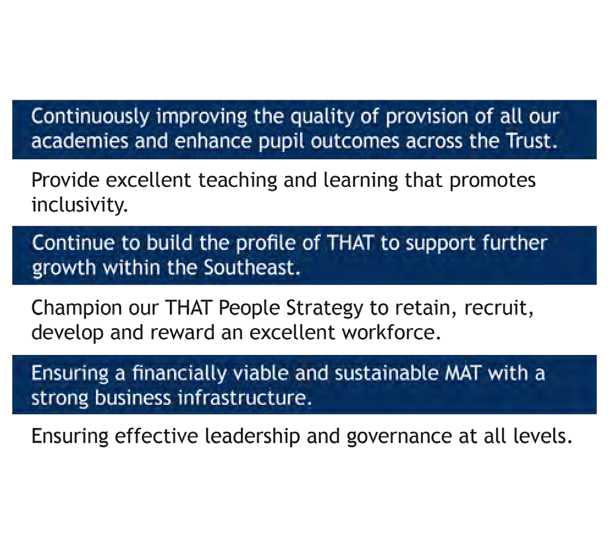

***Working together to build a community of successful learners***

**Vision and Values**

Learning and growth are at the heart of The Howard Academy Trust ethos. We strongly advocate that all members of our community have the opportunity to become the very best that they can be. We recognise and value the unique talents and expertise within our community and aim to create a culture of dignity, inclusivity, respect and ambition, where all can thrive.

This is achieved through:

Regular opportunities for collaborative CPD to ensure best practice across academies;

The highest standards of behaviour and conduct achieved through clear expectations and positive relationships;

Shared whole Trust values of dignity, respect and ambition;

Each academy is a hub for its local community and families;

A centralised team that allows academies leaders to focus on their core purpose of education.

**Strategic Priorities**

**Facing outwards and working in collaboration with other organisations and stakeholders;**

**High aspirations for all involved with the Trust and a solutions led approach;**

**The unique character of each academy is valued and contributes to the THAT whole Trust ethos;**

**A proactive network for joint working across academies, for staff at various career stages;**

**Excellent teaching and learning that promotes inclusivity;**



**Our Family**

of Schools

**The Howard School** 1,500 Pupils on Roll Rated Good by Ofsted Located in Rainham, Kent

**Temple Mill Primary School**

240 Pupils on Roll Rated Good by Ofsted Located in Strood, Kent

The Howard

School

**Deanwood Primary School**

230 Pupils on Roll Rated Good by Ofsted

Located in Rainham, Kent

**Thames View Primary School**

468 Pupils on Roll Rated Good by Ofsted

Located in Rainham, Kent

Deanwood

Primary School

**Miers Court Primary School**

400 Pupils on Roll Rated Good by Ofsted

Located in Rainham, Kent

**Waterfront UTC**

250 Pupils on Roll

Located in Gillingham, Kent

Further information about our academies can be found at [www.thatrust.org.uk](http://www.thatrust.org.uk/)

Miers Court

Primary School

Waterfront

UTC

Thames View

Primary School

Temple Mill

Primary School



**Working for**

The Howard Academy Trust

The Howard Academy Trust is very pleased to offer our staff a vast range of benefits, both professional and personal, as we believe that our excellent teaching and support staff should be supported at work and rewarded for the great work they do. Since 2018, The Howard Academy Trust has received the Gold Kent & Medway Workplace Wellbeing Award and we continue to make advances in emotional, physical and professional wellbeing.

Financial

•

A competitive salary for both teaching and support staff, with annual pay progression and a robust performance development scheme underway.

All staff are automatically enrolled into the Teacher and Local Government pension scheme with attractive employer contribution rates.

We have introduced Access EarlyPay through our payroll system as a mobile app that lets users draw down a proportion of their salary. You can withdraw at any point, 24/7 with just a few taps on your mobile phone. This money will then appear in your bank account within minutes.

•

•

Professional Development

•

Early finish for teaching staff every Friday afternoon to allow for whole school CPD, PPA, departmental training, and wellbeing afternoons.

Trust-wide training events and Trust Day events to bring all staff across the Trust together to network and share experiences.

Assessment Only routes and Schools Direct opportunities to take your first step into Teaching.

Access to 30 Level 2 qualifications through The Skills Network, free of charge to all staff. Career Progression and upskilling opportunities across the Trust.

Access in-house training in to Middle & Senior Leadership courses for future leaders.

•

•

•

•

•



Wellbeing

•

Full Time support staff receive 23 days annual leave as standard plus bank holidays, to increase after 5 years of service.

Each of our academies have received the Gold Kent & Medway Workplace Wellbeing Award in 2021.

Employee Assistance Programme, 24/7 access to a free counselling service for our employees and their families, for confidential advice and guidance.

Access to Senior Mental Health First Aiders and a team of established Mental Health First Aiders based at all of our academies.

Hosts of Medway Council’s wellbeing afternoons consisting of use of a health check machine, blood pressure checks, alcohol awareness speakers.

Flu jabs available for free every autumn for all staff, at their own academy for ease of access.

Discounted gym membership at Avenue Tennis, Gillingham, on a range of different packages.

Mindfulness taster sessions.

•

•

•

•

•

•

•

Facilities

•

Discounted hire of the school facilities, halls, fields, and gyms, for all members of staff up to 20%.

On site catering at our school canteens for breakfast items and a full lunch menu. Free car parking at each Trust site.

•

•

*Hear from staff across the Trust*



**Welcome to**

Temple Mill Primary School

Welcome to Temple Mill, a caring, friendly and inclusive environment that enables children to achieve all they can. We are privileged to have such wonderful children at Temple Mill, and we will always aim to ensure that every child gets nothing less than the very best they deserve.

We are a single form entry school with eight classes in, from Nursery to Year 6. As a small school, we soon get to know each other and we are pleased to enjoy positive partnerships with our parents and families.

We are developing an exciting enquiry led curriculum which is inspired by inquisitive learners and dedicated to giving our children a broad experience and deeper understanding of the topics they cover. Our aim is to equip children with the skills, knowledge and understanding to enable them to make informed decisions about the important things in their lives. Our school will provide solid foundations that children can take forwards into their futures.

We want each and every child and parent to say the Temple Mill name with pride. We promote our uniform, a sense of belonging and that everyone’s contribution is valued. We have a strong child voice here and it is influential in driving and supporting school improvement.

If you would like to know more about our school, you are welcome to come and visit. At Temple Mill our children very much enjoy talking about their progress and their pride in being part of the Temple Mill family.

We look forward to receiving your application.

*Mrs Lewis,*

**Head of School**



Temple Mill Primary School is a community primary school serving the full primary age range from 3 to 11. At present there are 210 children on roll. On 1 December 2015 Temple Mill Primary School became part of the Howard Academy Trust.

**School Characteristics**

NOR:

Age Range: Gender of Pupils: OFSTED Rating:

Disadvantage (PP+FSM): SEN:

EAL:

211

3-11

Mixed Good 32%

13% (2020-2021)

17%

*Hear from our current staff*

Temple Mill Primary School is sponsored by The Howard Academy Trust. Outcomes for children have increased substantially over the last year moving the school into the top ten highest achieving schools in Medway.

**Job**

Description

Nursery Teacher

EYFS

Head of School MPS/UPS

**Job Title: Department: Responsible to:**

**Renumeration:**

**General description of the post**

The holder of this post is expected to carry out the professional duties of a Nursery Teacher as described below, as circumstances may require and in accordance with the school’s policies under the direction of the Head of School and as set out in the school’s Teacher’s Pay and Conditions Document. The post-holder is required to fully support the

vision, ethos and policies of the school.

**School Improvement Plan Priorities**

Teaching Staff within the school are expected to make a valuable contribution to the

School Improvement Plan priorities for the current academic year:

•

To ensure that the percentage of children achieving at the expected level is at or above the national average both for Year 1 phonics and at the end of each Key Stage

To further raise the quality of teaching and learning by implementing strategies to enhance the development of mastery across the curriculum

To further develop the middle leaders within the school

To further enhance the quality of our provision for Personal Development, Behaviour and Welfare so that it is graded as outstanding

•

•

•

**Report to:**

•

•

The Head of School

The post holder is responsible for line managing any members of staff for which the Head of School delegates line management responsibility.

**Values and behaviour**

Teaching Staff play a vital role in assisting teaching staff to make the education of their students their first concern, and are accountable for achieving the highest possible standards in work and conduct. All members of staff must act with honesty and integrity; have strong knowledge within their field, keep their knowledge and skills up-to-date and are self-critical; forge positive professional relationships; and work with parents in the

best interests of the students in the school.

**Personal and professional conduct**

The classroom teacher is expected to demonstrate good standards of personal and professional conduct. The following statements define the behaviour and attitudes which

set the required standard for conduct throughout your career.

It is important to maintain high standards of ethics and behaviour, within and outside

school, by:

•

treating pupils with dignity, building relationships rooted in mutual respect, and at all times observing proper boundaries appropriate to the position;

having regard for the need to safeguard pupils’ well-being, in accordance with statutory provisions;

showing tolerance of and respect for the rights of others and not undermining fundamental British values, including:

* democracy, the rule of law, individual liberty and mutual respect, and
* tolerance of those with different faiths and beliefs;

ensuring that personal beliefs are not expressed in ways which exploit pupils’ vulnerability or might lead them to break the law.

•

•

•

Teaching Staff must have proper and professional regard for the ethos, policies and

practices of the school in which they work, and maintain high standards in their own attendance and punctuality.

**Responsibilities**

The post holder is accountable to their line manager at all times.

The appraisal process is the vehicle for determining the performance of a teacher and this assessment will directly relate to pay determination (in accordance with the school pay policy), CPD provision and career advancement (in accordance with the school CPD

policy).

**Classroom Teacher**

**Duties and responsibilities specific to the post:**

•

Be an excellent classroom practitioner adapting teaching styles to suit all groups of learners

Ensure planning of work is differentiated appropriately and evaluate the impact on progress and attainment for all groups of learners

Use assessment to set clear targets for improvement of pupils’ achievement and monitor pupils’ progress towards those targets

Use appropriate teaching learning strategies to communicate clear learning objectives and expectations for achieving excellence

Secure a good standard of behaviour for learning within the classroom through establishing appropriate rules and high expectations which pupils respect, acting to pre-empt and deal with inappropriate behaviour in the context of the school’s behaviour policy

Be familiar with the SEND Code of Practice and support and plan for pupils’ needs accordingly

Evaluate your own teaching critically to improve effectiveness

To work as part of a strong team to evaluate and accurately assess children’s learning needs

To encourage children’s initiative, creativity, responsibilities and independence

•

•

•

•

•

•

•

•

**Curriculum leadership responsibilities:**

•

•

•

•

Develop expertise in the subject area

Keep abreast of the subject area through research and CPD Act as a consultant to other staff

Produce, in consultation with colleagues, written policies and guidance; lead staff in the discussion of policy

Oversee the effective use of curriculum resources

Ensure legal compliance with statutory curriculum guidance Coach colleagues to ensure good practice

Monitor and assist in the evaluation of the delivery of a subject area across the school

Network and liaise with colleagues in other schools to ensure equity and continuity

Assist in the development of appropriate syllabuses, resources, schemes of work, marking policies and teaching strategies throughout the school

•

•

•

•

•

•

**Strategic direction and development:**

•

•

•

•

Formulate and support the aims, ethos, vision and policies of the school Develop positive working relationships and sustain motivation

Contribute to the achievement and implementation of the school’s development

Contribute to the school’s self-evaluation

•

Develop, implement, monitor and maintain policies and practices which reflect the school’s commitment to high achievement and which are consistent with national and school strategies and policies

Develop links with the wider community, especially parents

•

**Generic duties and responsibilities:**

•

All teachers – with the support of the school’s designated DCPC - have a responsibility for providing and safeguarding the welfare of children and young people

To be familiar with and support any health and safety procedures and medical routines

To attend meetings in school and outside school, as appropriate to the role

Positively promote the school’s policies on Equal Opportunities

•

•

•

**The duties and responsibilities detailed within this job description should be supplemented by those accountabilities, roles and responsibilities common to all classroom teachers, as set out within the School Teachers Pay and Conditions**

**Document.**

**Conditions of Employment:**

The post is graded at MPS/UPS.

This Job Description does not form part of the Contract of Employment and the duties may be varied to meet the changing demands of the school at the reasonable discretion

of the Head of School and following consultation with you.

**Person**

Specification

**Post:** Nursery Teacher

Please refer to these requirements when completing the application. The person specification is related to the requirements of the post as determined by the job description.

Essential

Desirable

Education and Qualifications

* Teaching Qualifications
* Degree or equivalent
* Willingness to undertake CPD
* Further Degree
* Evidence of ongoing Professional Development

Experience

* Excellent oral and written communication skills
* Record of successful teaching with a clear understanding of the teaching provision required
* Excellent classroom practice
* An ability to plan the curriculum to match the needs of the children in the class and a thorough understanding of assessment for learning
* Ability to implement a range of teaching strategies
* Experience of promoting highly effective communications within and between teams and other stakeholders in the community

Knowledge and Understanding

* Effective use of data to analyse performance and manage interventions to measure the impact this can have on achievement and attainment
* Good understanding of effective procedures for managing and promoting positive behaviour among pupils
* Good understanding of equal opportunity issues within the workplace and the importance of

culture and ethos and how this impacts on morale, high expectation and high standards

* Good understanding of equality of opportunity issues and how they can be effectively addressed in schools
* Clear understanding of the role of parents and the community in school improvement and how this can be practised and developed

Characteristics and Competencies

* Ability to promote the school’s aims positively
* Ability to develop good personal relationships within a team; making an effective contribution to high morale
* Ability to create a happy, challenging and effective learning environment
* A solution-focussed mind-set and determined “no- excuses” approach to raising standards
* A personable nature to build effective relationships with parents and all members of the school community
* A creative and good humoured approach to all aspects of teaching, management and leadership
* Ability to keep up to date on relevant policies and procedures in line with the duties identified in the job description
* Ability to work to professional standards, to develop effective working relationships, think independently and make judgements and to influence others through persuasion/discussion
* Ability to be flexible and well organised to manage, at times, unpredictable and variable workloads
* Ability and keenness to promote the school’s positive culture and ethos

**Application**

Process

We will review applications as they are received and contact those shortlisted for interview. Early applications are encouraged as we will close the recruitment process

once a suitable candidate is appointed.

Applicants should send their completed application pack to [hr@thatrust.org.uk.](mailto:hr@thatrust.org.uk)

**Closing Date:**

**Interviews:**

Friday 20 May 2022

TBC

This specification sets out the criteria which will be used to shortlist candidates for interview and during the interview process. After the closing date for this post a panel will conduct the shortlisting process. You will be selected for interview based entirely on the contents of your application form, it is therefore important that you fully read the Job Description and Person Specification prior to completing your form. After the shortlisting process has been completed candidates who have been selected for interview will be informed, and provided with full details of the interview programme. If you have not heard from us within 10 working days of the closing date for this post, you have, on

this occasion, unfortunately been unsuccessful.

We hope you find the information in this pack useful. Should you have any further queries or concerns, please do not hesitate to contact Sharon Teachen, HR Manager, on 01634 265771 or email [hr@thatrust.org.uk.](mailto:hr@thatrust.org.uk)