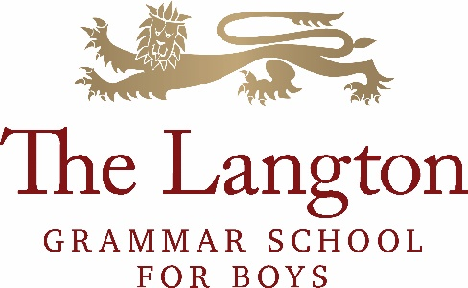

THE MFL DEPARTMENT
The Modern Foreign Language Department consists of a committed, enthusiastic and energetic team of language teachers, both native and non-native speakers as well as the Foreign Language Assistants who play an important role in developing students’ spoken competence and confidence whilst also raising students’ awareness of the culture of countries where the target language is spoken.
Our aim is to develop a life-long love of language learning in our students, to build their cultural awareness and to ensure that every student is able to reach his/her full potential. We will achieve this by delivering outstanding language lessons, which are well-structured, engaging and relevant to learners.
All students will begin studying two languages in Year 7 which they will carry forward into Year 8. Students are strongly advised to continue with at least one language in Year 9 and those who demonstrate a flair for languages have the option to continue with their second language in Year 9. In Years 10 and 11 students will work towards a GCSE qualification in one or two of their chosen languages. With a strong record of results, many students seek opportunities to read languages at top universities as a single or joints honours degree after completing their A Levels at our school.
We currently have links with schools in France, Germany and Spain and the department organises exchanges and visits abroad each year along with other enrichment opportunities organised by the MFL Society within the school.
About the German Department
German is a successful and well regarded subject within the school and the German Department will have brand new teaching rooms in the new building from September 2022. There is a commitment to an academic approach to language teaching: cross-curricular links, grammar and literature (6th form) are important elements of every course.

At Key Stage 3, there are mixed ability classes, yet we aim to offer a challenging and enjoyable range of activities to suit our students’ needs; students are well motivated and produce very good work. At Key Stage 4, students are taught in mixed ability option groups. At times, there are bi-lingual students who are fast-tracked. The department follows the AQA specification at GCSE and results are consistently good to very good.
The cohorts for A Level classes consist of internal and external students, and tend to be smaller classes. Whilst A Level teaching is usually shared between two members of staff, it will be one teacher who takes sole responsibility from September 2022. Preferably, the successful candidate would also be able to prepare students for Oxbridge applications; some students go on to read German at Russell Group universities. We follow the Edexcel German course.
The German department offers a range of activities to enhance the students’ experiences. Annual exchange trips to Flensburg for KS4 and Berlin for KS5 form part of the enrichment programme, in addition to the cross-curricular study trip to Berlin and a theatre trip for year 9. In the past, students have successfully applied for and participated in projects linked to UKGerman Connection. The department also benefits from a permanently employed language assistant who works with students in Key Stages 4 and 5 and assists with the preparation of oral assessments. Student teachers from the University of Heidelberg assist the department during their 3 to 6 month internships.

The successful applicant will be required to teach throughout all key stages. We are looking to appoint a German specialist with excellent subject knowledge and expertise, highly motivated, experienced and motivated, and who can communicate their enthusiasm for German to our students. The successful candidate will display a passion for the subject and an innovative approach to delivering German at different levels. The appointee will be someone who will enjoy being part of a highly motivated and successful team whilst also taking a lead role in promoting German further within the school.

